MENG 4010 – INDUSTRIAL NETWORKING
Lab 10 Report – VLAN Segmentation Using SCALANCE XB208

Item | Details
Student | Michael McCorkell (N01500049)
Course | MENG 4010 – Industrial Networking
Lab Date | October 8th 2026
Switch | Siemens SCALANCE XB208 managed switch (PROFINET name stn6xbscalancece63), management IP 10.116.254.156
End devices used | Siemens S7-1200 G2 (10.116.254.157), SIMATIC-PC (10.116.254.155), SIMATIC-HMI (10.116.254.158), Allen-Bradley ControlLogix (10.116.254.212)
Software / tools | SCALANCE XB208 Web-Based Management (WBM) — built-in ping tool and VLAN/port tables; Windows Command Prompt (ping)

Instructor’s Confirmation
The course instructor’s signature below verifies completion of the lab demonstration.

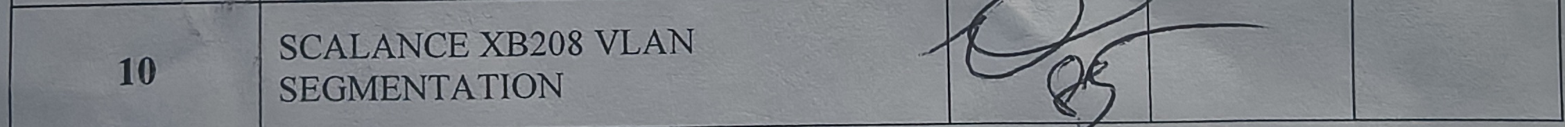

1. Assignment Summary

1.1 Objectives
This lab configured VLAN segmentation on a Siemens SCALANCE XB208 managed industrial switch, to logically separate traffic within an industrial Ethernet network. By the end of the lab the goal was to be able to:
- Understand and explain the function of VLANs in industrial networking.
- Configure 802.1Q VLANs through the switch’s Web-Based Management (WBM) interface.
- Create VLAN segments on a single switch and assign ports to them.
- Test VLAN isolation and connectivity using ping.

1.2 Work Completed
Baseline connectivity to the lab’s five devices — the SCALANCE XB208 itself (10.116.254.156), a Siemens S7-1200 G2 (10.116.254.157), a SIMATIC-PC (10.116.254.155), a SIMATIC-HMI (10.116.254.158), and an Allen-Bradley ControlLogix PLC (10.116.254.212) — was confirmed with the switch’s own ping tool and with Windows ping before any VLAN was configured, while every device still shared the default VLAN 1.
Two VLANs were then created on the XB208 under 802.1Q VLAN Bridge mode: VLAN 1, named “admin” (the host computer and the switch’s own management interface), and VLAN 2, named “field_items” (the field devices on ports P0.2 and P0.3). Each port’s VLAN membership and Port VID (the VLAN untagged traffic on that port is assigned to) were set so that P0.2 and P0.3 belong to VLAN 2 and every other port remains on VLAN 1. The first attempt left the Port VID of P0.2 on VLAN 1 even though it had been added as a VLAN 2 member, which was corrected in a second pass (Section 2.4).
With the VLANs active, ping tests were run from a PC on VLAN 1 and from a PC on VLAN 2 to confirm isolation: a VLAN 1 host could reach the switch’s management IP but not a VLAN 2 device, and a VLAN 2 host could not reach the switch’s management IP. The exception was 10.116.254.158, which a VLAN 2 host could still reach even after the ports were assigned — an error traced back to the Port VID mismatch described above — and which was resolved once the Port VID table was corrected.

1.3 Conclusions
VLAN segmentation on the SCALANCE XB208 worked once both the VLAN membership table and the Port VID of every port agreed with each other. Setting a port’s VLAN membership alone was not sufficient — the Port VID had to be changed as well, and leaving the two inconsistent (Section 2.4–2.5) produced a real, observed security gap rather than a configuration that simply failed to take effect: a VLAN 2 host could ping 10.116.254.158 until the Port VID was corrected, after which the same ping correctly failed. The overall result demonstrates the intended behaviour: VLAN 1 can reach the switch’s management interface but not VLAN 2 devices, and VLAN 2 cannot reach the switch’s management interface.

2. Configuration Evidence

2.1 Switch identification and discovered devices
The XB208’s own status page confirms its management address and identity, and its discovery table lists every device the switch could see on the network before VLAN segmentation was applied — useful as a record of the flat, pre-VLAN network.
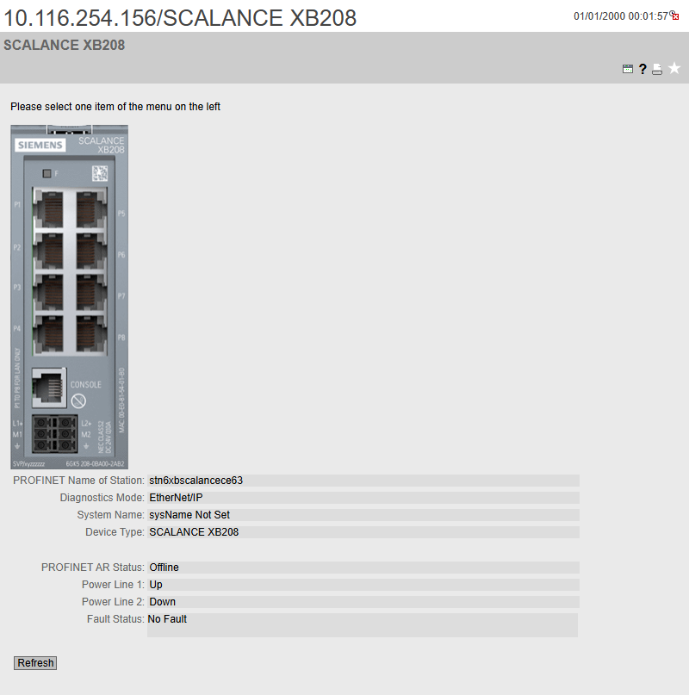
Figure 1 – SCALANCE XB208 status page: IP 10.116.254.156, PROFINET name stn6xbscalancece63, Diagnostics Mode EtherNet/IP, Power Line 1 up, No Fault
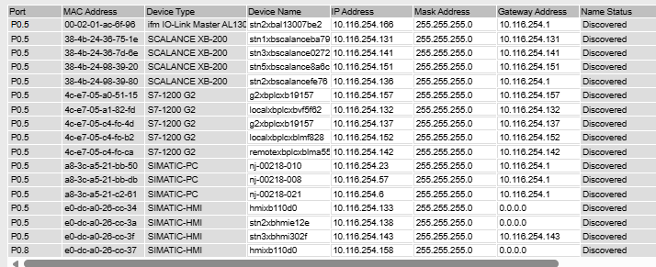
Figure 2 – Discovered devices table (pre-VLAN): all SCALANCE XB-200 switches, S7-1200 G2 controllers, SIMATIC-PC and SIMATIC-HMI units visible from this switch, with their MAC/IP/mask/gateway
Comparing this table against the assigned IP address plan for this trainer (Scalance XB-200 management: .156; S7-1200 G2: .157; SIMATIC-PC: .155; HMI: .158; Allen-Bradley: .212) showed that not every device matched its assigned address — two SIMATIC-HMI entries (10.116.254.133 and .138) show a gateway of 0.0.0.0 instead of 10.116.254.1, unlike every other discovered device. This is flagged again in Section 3.2.

2.2 Baseline connectivity (pre-VLAN)
Before any VLAN was configured, every target device was reachable both from the switch’s own built-in ping tool and from a Windows command prompt, confirming the flat network was fully connected end to end.
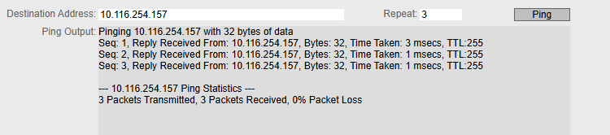  Figure 3 – Switch WBM ping tool → 10.116.254.157 (S7-1200 G2): 3/3 replies, TTL 255 | 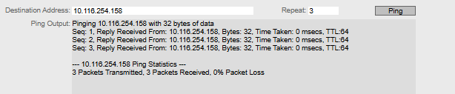  Figure 4 – Switch WBM ping tool → 10.116.254.158 (HMI): 3/3 replies, TTL 64
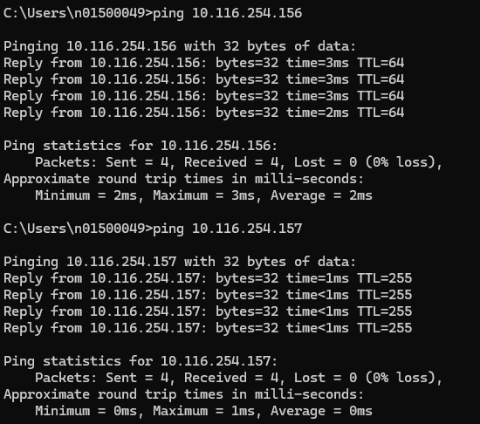
Figure 5 – Windows ping to 10.116.254.156 (switch) then 10.116.254.157 (S7-1200 G2): both 0% loss
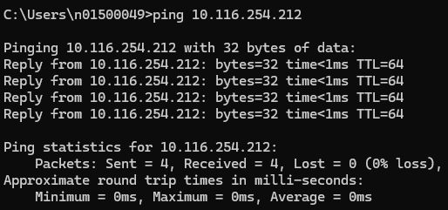  Figure 6 – Windows ping to 10.116.254.212 (Allen-Bradley PLC): 0% loss | 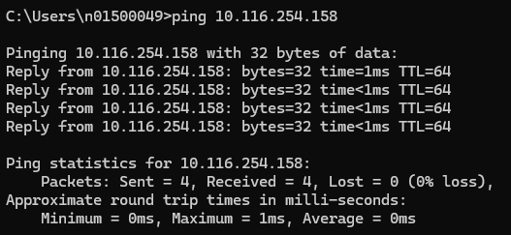  Figure 7 – Windows ping to 10.116.254.158 (HMI): 0% loss, TTL 64

2.3 VLAN creation
VLAN mode was enabled on the switch (802.1Q VLAN Bridge). Initially only the default VLAN 1 existed, with all eight ports as untagged members. VLAN 2 was then created and named “field_items”, alongside VLAN 1 renamed “admin”; ports P0.2 and P0.3 were added as members of VLAN 2 (shown as lowercase “u”, an untagged member whose Port VID still pointed elsewhere at this stage) while the remaining ports stayed untagged members of VLAN 1.
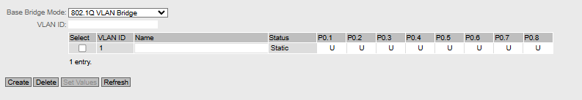
Figure 8 – VLAN Bridge table before segmentation: only VLAN 1 exists, all 8 ports untagged members (U)
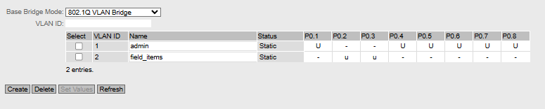
Figure 9 – VLAN Bridge table after creating VLAN 2 “field_items”: P0.2 and P0.3 added as members (lowercase u); VLAN 1 “admin” keeps the remaining ports

2.4 Port VID assignment — first attempt (inconsistent)
The Port VID table controls which VLAN untagged frames on each port are assigned to. In the first pass, P0.3 was correctly set to VLAN 2, but P0.2 was left on VLAN 1 even though the VLAN Bridge table (Figure 9) already listed it as a VLAN 2 member. This mismatch — a port that is a member of VLAN 2 but whose Port VID still points to VLAN 1 — is the root cause of the VLAN 2 leak described in Section 2.6.
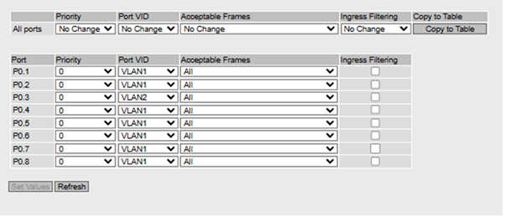
Figure 10 – Port VID table, first attempt: P0.1=VLAN1, P0.2=VLAN1 (inconsistent with Figure 9), P0.3=VLAN2, P0.4–P0.8=VLAN1

2.5 Port VID assignment — corrected
The Port VID table was corrected so that P0.2 and P0.3 both carry Port VID = VLAN 2, matching their VLAN Bridge membership, while every other port remains on VLAN 1.
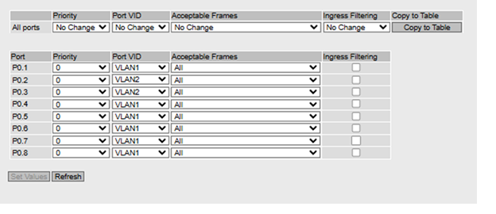
Figure 11 – Port VID table, corrected: P0.1=VLAN1, P0.2=VLAN2, P0.3=VLAN2, P0.4–P0.8=VLAN1

2.6 Ping test results — VLAN 1
From a PC connected to a VLAN 1 (admin) port, the switch’s management address was reachable, and a device assigned to VLAN 2 was not — matching the expected VLAN 1 behaviour exactly.
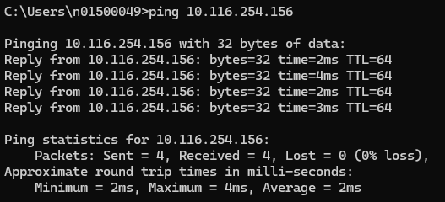  Figure 12 – VLAN 1 host → 10.116.254.156 (switch management): 0% loss, succeeds as expected | 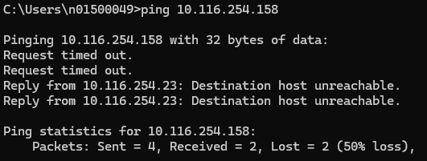  Figure 13 – VLAN 1 host → 10.116.254.158 (VLAN 2 device): request timed out / destination host unreachable, correctly fails

2.7 Ping test results — VLAN 2
From a PC connected to a VLAN 2 (field_items) port, the switch’s management address correctly failed to respond. However, a ping to 10.116.254.158 still succeeded in full at this point — the leak caused by the Port VID mismatch in Section 2.4, since P0.2’s Port VID was still VLAN 1 when this test was first run.
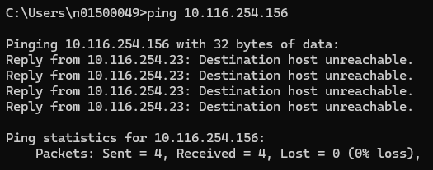
Figure 14 – VLAN 2 host → 10.116.254.156 (switch management): destination host unreachable, correctly fails
Figure 15 – VLAN 2 host → 10.116.254.158: 0% loss — unexpected success, the VLAN 2 isolation error caused by the Port VID mismatch in Figure 11
After correcting the Port VID table (Figure 12), the same ping was repeated and now correctly failed, confirming the fix resolved the isolation gap.
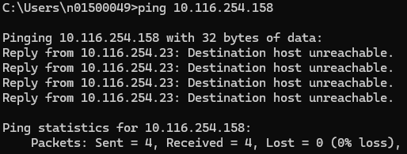
Figure 16 – VLAN 2 host → 10.116.254.158, re-tested after the Port VID fix: destination host unreachable — correct isolation

3. Results and Reflection

3.1 Link to theory
An 802.1Q VLAN works by tagging which logical network each frame belongs to, but an access port does not add that tag itself — it relies on its Port VID (PVID) to decide which VLAN an incoming untagged frame is treated as belonging to. Adding a port to a VLAN’s membership table only controls which VLANs that port is allowed to forward traffic for; it does not by itself change which VLAN the port’s own untagged traffic is assigned to. That is exactly why P0.2 in Section 2.4 could be a listed member of VLAN 2 and still behave like a VLAN 1 port until its PVID was changed to match — the membership table and the PVID setting have to agree, or the port behaves according to whichever one the switch consults for a given direction of traffic.
This also explains why VLAN 1 could reach the switch’s own management interface while VLAN 2 could not (Figures 13 and 15): the switch’s management interface sits logically on VLAN 1, so only ports whose PVID is VLAN 1 are treated as part of that network for untagged management traffic.

3.2 Errors and limitations
- Port VID / VLAN membership mismatch (the main finding of this lab). P0.2 was added to VLAN 2’s membership table (Figure 9) before its Port VID was updated (Figure 11 still shows VLAN 1), which let a VLAN 2 host reach 10.116.254.158 when it should not have been able to (Figure 7, reused). This was corrected in Figure 12 and re-verified in Figure 16. This is worth keeping in the report exactly as it happened — it is good evidence of understanding the difference between VLAN membership and Port VID, which is the core concept the lab is testing.
- Inconsistent IP assignment on the discovered-devices table. Two SIMATIC-HMI entries in Figure 3 (10.116.254.133 and .138) show gateway 0.0.0.0 while every other discovered device shows 10.116.254.1. This matches the note that “some [IPs were] right but some wrong from the assigned IPs” and suggests one or more HMI units on the trainer had an incomplete or default network configuration rather than the lab’s intended static settings.
- VLAN 1 → VLAN 2 ping used a mixed/ambiguous result. Figure 14 (VLAN 1 host pinging the VLAN 2 device at .158) shows two requests timing out followed by two “destination host unreachable” replies from 10.116.254.23, rather than four consistent results. The overall outcome is still a correct failure — no reply ever came from .158 itself — but a cleaner single-mode result (four unreachable, or four timeouts) would be stronger evidence for the report.

3.3 Possible improvements
- When adding a port to a new VLAN, change its Port VID in the same pass as its VLAN membership, rather than as two separate steps — this lab’s own result shows how easily the two can be left out of sync.
- Re-run the VLAN 1 → VLAN 2 ping test once more to get a clean, single-mode result (all four requests timing out or all four returning host-unreachable) for a tidier record.
- Add a simple labeled diagram showing which device is wired to which XB208 port and which VLAN that port belongs to, to satisfy the “port assignment diagram” requirement directly.
- Investigate and correct the two SIMATIC-HMI units showing a 0.0.0.0 gateway in the discovered-devices table, so every device matches its assigned IP configuration exactly.
- If time allows, attempt the optional Scenario 2 extension — trunking VLAN 2 across two XB208 switches via P0.8 — which would also demonstrate the trunk-port concept this single-switch lab does not cover.

